Job Advertisement Analysis Pipeline
Part 1 — Data Preparation & Preprocessing
Final Project Documentation

1. Introduction
This document covers the data preparation phase of a two-stage NLP pipeline for analysing German-language job advertisements. The pipeline is built by three team members working sequentially:

Person | Role | Depends on
Person 1 | Data preparation (this document) | —
Person 2 | BERT training & evaluation | train_dataset.pt, test_dataset.pt, id2label.json
Person 3 | LLM skill extraction | best_model.pt, id2label.json (from Person 2)

2. Dataset Description

2.1 Source and Structure
The dataset is provided in annotated.json, created using Label Studio. It contains German-language job advertisements with manually assigned zone labels. Each entry has two relevant fields:

- data['content_clean'] — the full raw text of the job advertisement
- annotations[0]['result'] — a list of labeled spans, each with character offsets (value['start'], value['end']) and a zone label (value['labels'])

2.2 Size and Quality
Metric | Value
Raw entries | 2,699
Removed (unannotated) | 11
Clean dataset | 2,688
Total labeled spans | 19,666
Shortest / longest job ad (after cleaning) | 101 / 19,598 chars
Average length | 1,591 characters
Entries exceeding 512 tokens (estimated) | ~687 (25.6%)

The 11 removed entries fell into three categories: French-language ads with no annotations (5), HTML/URL-encoded unreadable text (2), and corrupted crawler output or error pages (4).

Note: French language alone was not the reason for removal. bert-base-multilingual-cased supports French. The problem was the absence of annotations — training on unannotated text would incorrectly label all those tokens as O.

2.3 Zone Labels
The dataset contains 10 distinct zone labels. The project specification lists 8 — two additional labels (Firmenkundenbeschreibung, Arbeitsumfeld) were found during exploration and included in the label mapping.

Label | Count | Share
Fähigkeiten und Inhalte | 5,208 | 26.5%
Anstellung | 4,001 | 20.3%
Bewerbungsprozess | 2,651 | 13.5%
Abschlüsse | 2,256 | 11.5%
Erfahrung | 1,918 | 9.8%
Benefits | 1,391 | 7.1%
Firmenbeschreibung | 1,303 | 6.6%
Firmenkundenbeschreibung | 769 | 3.9%
Challenges | 108 | 0.5%
Arbeitsumfeld | 61 | 0.3%
O (Outside — assigned in code, not by annotators) | — | —

Class imbalance (for Person 2): Challenges and Arbeitsumfeld together represent less than 1% of all spans. Without countermeasures the model would almost never learn these zones. This is addressed during training using class-weighted CrossEntropyLoss.

2.4 Annotation Quality
Character offsets (value['start'] and value['end']) were verified to reliably locate spans within content_clean. A minor inconsistency exists in value['text'], which stores escaped newlines (\\n) rather than real newline characters. Since the pipeline uses only the offsets — never value['text'] — this has no impact on processing.

3. Methodology

3.1 Script
The preprocessing script is based on the professor-provided preprocessing.py. Three targeted improvements were made, documented in Section 4.

3.2 Pipeline Steps
# | Step | Description
1 | Load & filter | Read annotated.json via pandas; remove 11 unannotated entries
2 | Tokenize | BertTokenizerFast splits text into sub-word tokens; offset_mapping links each token to its character position
3 | Label alignment | find_token_span() maps character-level annotation spans to token indices; unmatched tokens receive label O
4 | Sliding window | Job ads longer than 510 tokens are split into overlapping chunks (stride=256) to stay within BERT's 512-token limit
5 | Label encoding | String labels converted to integer IDs; label2id and id2label built dynamically and saved to id2label.json
6 | Dataset creation | 80/20 train/test split; sequences padded and converted to PyTorch TensorDatasets; saved as .pt files

3.3 Key Design Decisions
Tokenizer. BertTokenizerFast is required (not BertTokenizer) because only the Fast variant provides offset_mapping — essential for label alignment. The multilingual-cased model handles German umlauts and preserves capitalisation, which is meaningful in German.

Label alignment. For each token, its character range is checked against all annotation spans. If it falls inside a span it receives that label; otherwise it receives O. A fallback finds the nearest token when annotation boundaries land on whitespace or between sub-word tokens — preventing silent annotation loss.

Sliding window. ~25.6% of job ads exceed 512 tokens. Chunks overlap by stride=256 tokens so that tokens near boundaries appear with full context in at least one chunk, reducing information loss at splits.

Label padding (-100). Padding tokens receive label -100. PyTorch CrossEntropyLoss ignores these via ignore_index=-100, preventing the model from learning from padding. Using label2id['O'] (=0) would be ambiguous — the model cannot distinguish real O tokens from padding. The project's own data_preparation_doc acknowledges this: "Using -100 as the padding_value for labels here might align more directly with common practice for CrossEntropyLoss."

Robust annotation filter. The filter uses four defensive checks (isinstance, len>0, isinstance(x[0], dict), .get()) before accessing x[0]['result']. The original one-liner (len(x[0]['result']) > 0) would crash on malformed or empty annotation lists.

4. Changes to the Provided Script
Three improvements were made to preprocessing.py. Each is documented with a comment directly in the code.

# | What changed | Original | Improved
1 | Label padding in create_dataset() | padding_value=label2id['O'] | padding_value=-100
2 | Unused imports removed | TfidfVectorizer, cosine_similarity, numpy | (removed)
3 | Dataset saving uncommented | # torch.save(train_dataset, ...) | torch.save(train_dataset, ...)

5. Outputs
File | For | Contents
train_dataset.pt | Person 2 | PyTorch TensorDataset — 80% of processed chunks for training
test_dataset.pt | Person 2 | PyTorch TensorDataset — 20% of processed chunks for evaluation
id2label.json | Persons 2 & 3 | Maps integer IDs to zone label strings. Must travel with best_model.pt
preprocessing.log | All | Detailed log of every processing step, warning, and label discovery

Part 2 — BERT Training & Evaluation

7. Objective

The objective of Part 2 is to train a BERT-based token classification model that predicts the correct zone label for each token in a job advertisement.

The model receives the preprocessed token-level datasets from Part 1 and learns to classify each token into one of the predefined job-ad zones, such as Fähigkeiten und Inhalte, Abschlüsse, Erfahrung, Benefits, Bewerbungsprozess, or O.

The output of this part is a trained BERT model that can identify relevant text zones in unseen job advertisements. The most important zone for the next project step is Fähigkeiten und Inhalte, because this zone is later used as the input for Gemini-based skill extraction.

8. Input Files from Part 1

The training script uses the following files produced during preprocessing:
File | Purpose
train_dataset.pt | Training data containing token IDs, labels, and attention masks
test_dataset.pt | Test/validation data used to evaluate the model
id2label.json | Mapping from numeric label IDs back to readable zone names

The datasets are loaded using torch.load(). The label mapping is loaded from id2label.json, then reversed to create label2id.

The number of labels is derived dynamically:

num_labels = len(id2label)

In this project, the final number of labels was: 11 labels

9. Model Setup

The model used for training is:

bert-base-multilingual-cased

It was selected because the job advertisements are mainly German-language texts, and the multilingual cased BERT model can handle German characters, umlauts, and capitalization.

The model was initialized as:

BertForTokenClassification.from_pretrained(
MODEL_NAME,
num_labels=num_labels,
id2label=id2label,
label2id=label2id
)

This adds a token-classification layer on top of BERT. The pretrained BERT layers provide language understanding, while the new classification layer learns the project-specific zone labels.

During initialization, warnings appeared that classifier.weight and classifier.bias were newly initialized. This is expected because the final classifier layer is specific to our 11 zone labels and must be trained from scratch.

10. Training Environment

Training was executed locally using an NVIDIA GPU.

The environment check showed:

PyTorch version: 2.5.1+cu121
CUDA available: True
GPU: NVIDIA GeForce RTX 4060

The script automatically selects GPU if available:

device = torch.device("cuda" if torch.cuda.is_available() else "cpu")

The final training run used:

Using device: cuda

This was important because BERT training on CPU was too slow.

11. Training Configuration

The final training configuration was:
Parameter | Value
Model | bert-base-multilingual-cased
Epochs | 3
Batch size | 8
Gradient accumulation steps | 2
Effective batch size | 16
Learning rate | 2e-5
Optimizer | AdamW
Scheduler | Linear scheduler with warmup
Warmup ratio | 10%
Validation interval | Every 50 training steps
Loss function | Weighted CrossEntropyLoss
Padding ignore index | -100

Gradient accumulation was used to simulate a larger batch size without requiring too much GPU memory.

12. Class Imbalance Handling

The dataset is strongly imbalanced. Some labels occur very often, while rare labels such as Challenges and Arbeitsumfeld occur only a small number of times.

To address this, class weights were calculated from the training data. Labels with fewer examples received higher weights, so that the model would not ignore them during training.

The loss function was defined as:

torch.nn.CrossEntropyLoss(
weight=class_weights,
ignore_index=-100
)

The ignore_index=-100 setting is essential because Part 1 padded label sequences with -100. This prevents the model from learning from padding tokens.

The calculated class weights showed that rare classes received much larger weights. For example:

Challenges: high weight
Arbeitsumfeld: high weight

This confirms the strong class imbalance in the dataset.

13. Training Process

The training loop follows this process:

Load one batch
↓
Move input_ids, labels, and attention_mask to GPU
↓
Run BERT forward pass
↓
Calculate weighted loss
↓
Backpropagate loss
↓
Apply gradient accumulation
↓
Update model weights with AdamW
↓
Update learning rate scheduler
↓
Validate periodically
↓
Save best model if validation loss improves

The script saves two model checkpoints:
File | Meaning
best_student_model.pt | Model checkpoint with the best validation loss
final_student_model.pt | Final model after training finishes

The best model is the most important output for the next project phase.

14. TensorBoard Monitoring

TensorBoard was used to monitor the training process.

The following metrics were logged:

Loss/train_step
Loss/validation_step
Loss/validation_epoch
Accuracy/validation_step
Accuracy/validation_epoch
Learning_rate

The TensorBoard curves showed that:

Training loss decreased over time.
Validation loss also decreased.
Validation accuracy increased.

This indicates that the model learned useful patterns from the training data and that the training process was stable.

The validation accuracy reached approximately:

Validation accuracy: around 0.80

The validation loss decreased to approximately:

Validation loss: around 0.69

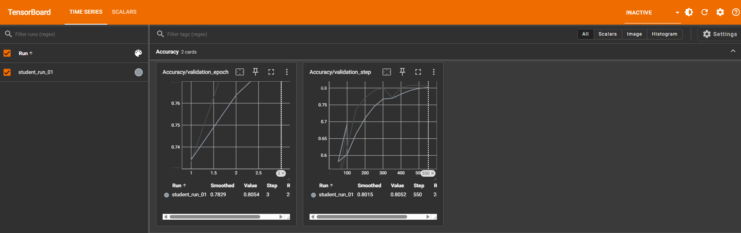

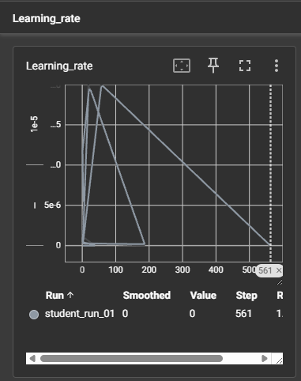

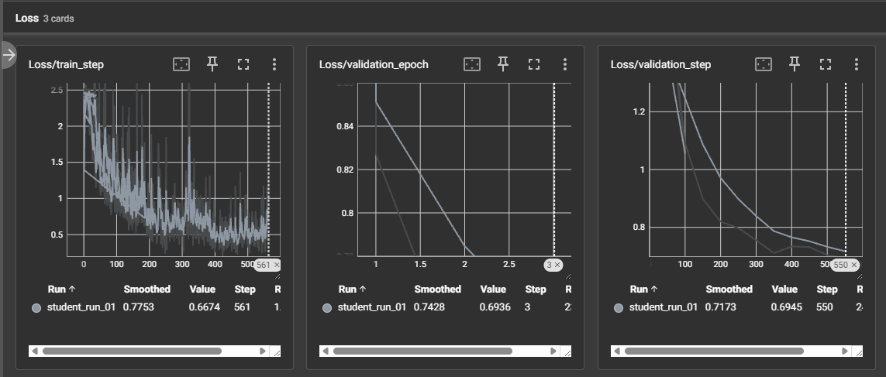

15. Final Evaluation

After training, the best model checkpoint was loaded and evaluated on the test set.

In addition to validation accuracy, a stricter sequence-level evaluation was performed using seqeval.

The final result was:
Metric | Value
Precision | 0.1746
Recall | 0.3190
F1-score | 0.2257

The detailed classification report showed that some labels were easier to predict than others. Frequent labels had better support, while rare labels such as Arbeitsumfeld and Challenges remained difficult.

16. Interpretation of Results

The model successfully trained and evaluated end-to-end. The decreasing training and validation loss show that the model learned from the data.

However, the final seqeval F1-score is still relatively low. This means that exact zone-span prediction remains challenging.

The difference between validation accuracy and F1-score is important:

Validation accuracy measures token-level correctness.
Seqeval F1-score measures stricter zone-span quality.

A model can achieve reasonable token-level accuracy while still struggling to predict exact zone boundaries. This is especially true for long job advertisements, overlapping zones, rare labels, and semantically similar categories.

Therefore, the result should be interpreted as:

The BERT training pipeline works successfully, but the model quality still leaves room for improvement.

19. Conclusion

Part 2 successfully implemented the BERT training and evaluation pipeline for job-ad zone prediction.

The model was trained using GPU acceleration, class-weighted loss, a learning-rate scheduler, and TensorBoard monitoring. The best model checkpoint was saved based on validation loss, and final evaluation was performed using precision, recall, and F1-score.

Although the final F1-score shows that zone prediction remains challenging, the project goal for this stage was achieved: a working BERT-based zone classifier was trained, evaluated, and prepared for handover to the Gemini skill extraction step.

17. Limitations

Several limitations were observed:

The dataset is imbalanced. Rare labels such as Challenges and Arbeitsumfeld have very few examples.

Some zone labels are semantically close, for example Firmenbeschreibung, Firmenkundenbeschreibung, and Arbeitsumfeld.

Token-level accuracy can look stronger than span-level F1 because exact zone boundaries are harder to predict.

The model was trained as a baseline and not extensively optimized.

Further experiments with capped class weights, different learning rates, or more detailed error analysis could improve performance.

Output for Person 3 — Gemini Skill Extraction
The output of Part 2 provides the foundation for Part 3 / Task 5.
Person 3 can use:
best_student_model.pt
id2label.json
The intended workflow is:
Raw job advertisement
↓
BERT predicts token-level zones
↓
Extract tokens predicted as Fähigkeiten und Inhalte
↓
Pass only this extracted zone text to Gemini
↓
Gemini returns clean 2–5 word skill phrases
This reduces the amount of text sent to Gemini and focuses the LLM on the most relevant part of the job advertisement.

Handover Notes

For Person 3 — LLM Skill Extraction
- Target zone: 'Fähigkeiten und Inhalte' — collect all tokens predicted with this label after BERT inference
- The same zone can appear multiple times non-contiguously in one job ad — collect all occurrences
- Load id2label.json to convert predicted integer IDs back to label strings
- Send reconstructed text segments to Gemini for skill extraction (2–5 word phrases)

